CHEMISTRY REVISION

- Fill in the table below:
Element | Classify the element as a metal, non-metal, noble gas, etc | Chemical symbol | Type of charge when this atom forms an ion? (if it forms an ion)
Example; potassium | metal | K | Positive (1+)
Chlorine
Magnesium
Neon
Oxygen

- Define the following;

Element Ion Compound Proton Halogen Alkali Metal Reactant Electron

Molecule Noble gas Product Atom Neutron Atomic Number Atomic Mass

3. a) How many atoms are there in a glucose molecule which has the formula = C₆H₁₂O₆ ?
b) How many different elements are in this glucose molecule?
c) How many Hydrogen atoms are there in this glucose molecule?

4. State the Law of Conservation of Matter

5. Explain why all the metals found in group 1 of the periodic table are very reactive, and readily form ions

6. For the equation shown:

CH₄ + O₂ → CO₂ + H₂O

a) Circle the reactants
b) Underline the products
c) Balance the equation

7. List and explain four things you could do to a reaction to increase its rate (make it go faster)

8. When hydrogen and nitrogen react, three hydrogen atoms join with one nitrogen atom to form ammonia. The formula for ammonia is:

- 3NH
- NH₃
- N₃H
- (NH)₃

9. Two or more atoms joined together form:

- an element
- a molecule
- a radical
- a nucleus

10. Two or more different elements joined together form:

- an atom
- an ion
- a compound
- a nucleus

- If an atom loses an electron it becomes:

- a positive ion
- a negative ion
- a neutron
- a compound

- How many oxygen atoms are there in one molecule of sulfuric acid, H₂SO₄?

- 1
- 2
- 4
- 7

- List the 5 main types of reactions

- Select the reaction which shows a single replacement reaction:
- CH₄ + 2O₂ → CO₂ + 2H₂O
- CaCO₃ → CaO + CO₂
- Fe + S → FeS
- 2AI + 6HCl → 2AICl₃ + 3H₂

- Select the reaction which shows a combustion reaction:
- CH₄ + 2O₂ → CO₂ + 2H₂O
- CaCO₃ → CaO + CO₂
- Fe + S → FeS
- 2AI + 6HCl → 2AICl₃ + 3H₂

- As you read down group 1 in the period table, from lithium to francium, what happens to the reactivity of the elements?
- It increases.
- It remains the same.
- It decreases.
- There is no pattern in the reactivity.

- Identify the correctly balanced chemical equation from the list.
- FeO₃ + 3CO → Fe + 2CO₂
- 2FeO₃ + 2CO → Fe + 3CO₂
- FeO₃ + 3CO → Fe + 3CO₂
- FeO₃ + 3CO → Fe + CO₂

- Identify the correctly balanced chemical equation from the list.
- Mg(OH)₂ + 2HCl → MgCl₂ + H₂O
- Mg(OH)₂ + 2HCl → MgCl₂ + 2H₂O
- Mg(OH)₂ + HCL → MgCl₂ + H₂O
- MgOH + 2HCl → MgCl₂ + 2H₂O

- Identify the element that has the electron arrangement 2,8,7?
- Fluorine
- Argon
- Chlorine
- Magnesium

- Group 1 elements are called?
- transition metals
- noble gases
- alkaline earth metals
- alkali metals

- Group 8 elements are called?
- noble gases
- transition elements
- halogens
- alkali metals

- Horizontal rows of the periodic table are called?
- periods
- columns
- groups
- sections

- Balance the following equations:

a) N₂ + H₂ → NH₃

b) Al + H₂SO₄ → Al₂ (SO₄)₃ + H₂

c) Na OH + H₃PO₄ → Na₃PO₄ + H₂O
- Complete the table below about each of the following elements:
Electron Configuration: | 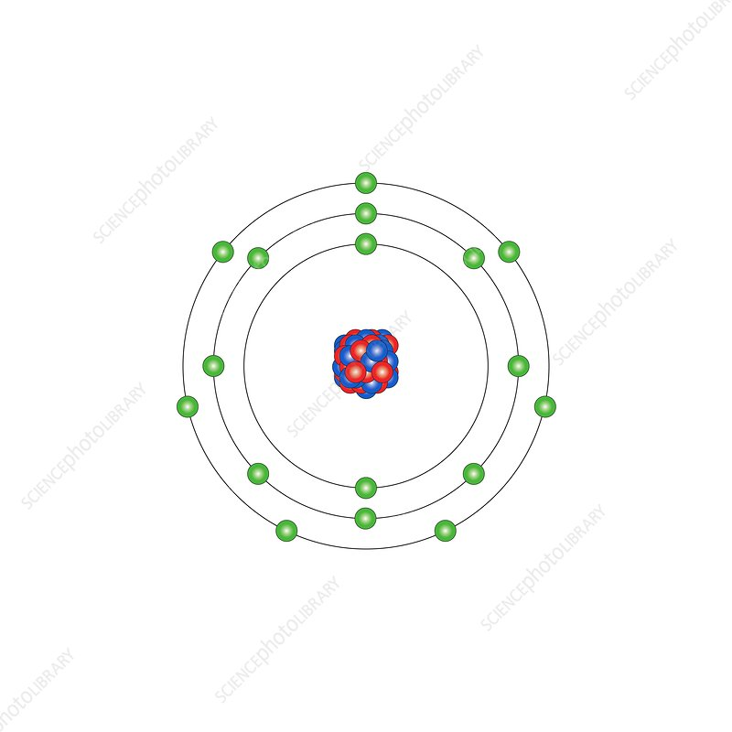 | 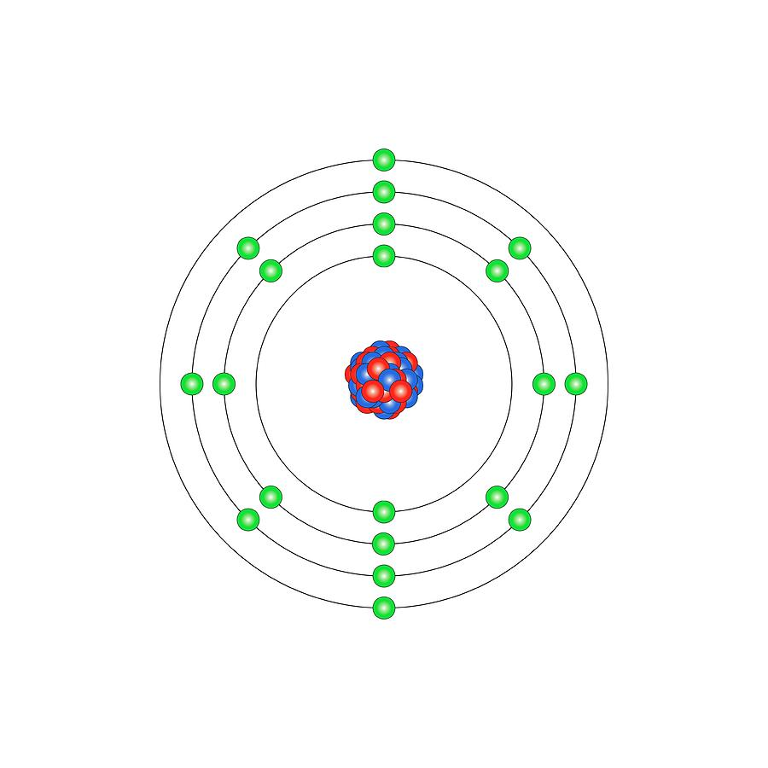 | 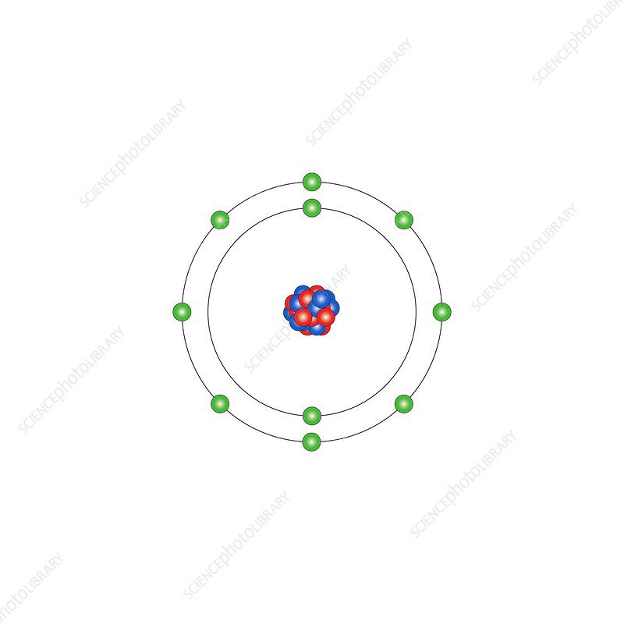
Name of Element:
Group it belongs to:
Name of another element that would have similar chemical properties to it:

- Use the attached ‘Chemical Formulas Reference sheet’ to write the formula for the following compounds:

a) Sodium fluoride
b) Calcium carbonate
c) Lead nitrate
d) Aluminium sulfate

26. Use the ‘Chemical Formulas Reference sheet’ to write a balanced equation for the following reaction using chemical symbols.

sodium carbonate + sulfuric acid (H₂SO₄) → sodium sulphate + carbon dioxide + water

27. The reaction between calcium solid and chlorine gas can be represented by the equation:
Ca(s) + Cl₂(g) → CaCl₂(s)

What term best describes this reaction?
- Precipitation
- Combination
- Decomposition
- Combustion.

28. When an electric current is conducted through liquid sodium chloride, NaCl, silvery
sodium metal and chlorine gas are produced. (This reaction only occurs at very high temperatures.) i.e. NaCl _{(l)} → Na _{(l)} + Cl_{2 (g)}

This is an example of which type of chemical reaction?
- Synthesis / Combination
- Decomposition
- Displacement
- Precipitation

29. Which one of the following will NOT increase the rate of a reaction?
- use more concentrated reactants
- add more of a reactant
- grind up the solid reactant
- heat the reactants up

30. Write a balanced chemical equation for the single replacement reaction between Silver
Nitrate and Copper (refer to Chemical Formulas Sheet).

31. Recall the ‘Effect of temperature on the Rate of Reaction’ experiment that was done in
class. Write down the:

a) independent variable
b) dependent variable
c) controlled variables
d) overall conclusion of the experiment

Chemical Formulas Reference Sheet

Table 1: Some common ions

POSITIVE IONS (CATIONS) |  |  | NEGATIVE IONS (ANIONS)
CHARGE | NAME | FORMULA | CHARGE | NAME | FORMULA
+1 | Ammonium | NH₄⁺ | -1 | Chloride | Cl⁻
+1 | Sodium | Na⁺ | -1 | Bromide | Br⁻
+1 | Potassium | K⁺ | -1 | Iodide | I⁻
+1 | Silver | Ag⁺ | -1 | Hydroxide | OH⁻
+2 | Magnesium | Mg⁺² | -1 | Nitrate | NO₃⁻
+2 | Calcium | Ca²⁺ | -2 | Oxide | O²⁻
+2 | Copper | Cu²⁺ | -2 | Sulfide | S²⁻
+2 | Zinc | Zn²⁺ | -2 | Carbonate | CO₃²⁻
+2 | Mercury | Hg²⁺ | -2 | Sulfate | SO₄²⁻
+3 | Boron | B³⁺ | -3 | Phosphide | P³⁻
+3 | Aluminium | Al³⁺ | -3 | Nitride | N³⁻
+3 | Gallium | Ga³⁺ | -3 | Phosphate | PO₄³⁻

Table 2: Some common gases

Br₂ | Bromine | CO₂ | Carbon dioxide | N₂ | Nitrogen
Cl₂ | Chlorine | H₂ | Hydrogen | NH₃ | Ammonia
CO | Carbon monoxide | SO₂ | Sulfur dioxide | O₂ | Oxygen
NO | Nitrogen monoxide

Table 3: Some common acids

HNO₃ | Nitric acid
H₂SO₄ | Sulfuric acid
H₃PO₄ | Phosphoric acid
H₂CO₃ | Carbonic acid
HCI | Hydrochloric acid

